**DAILY ONLINE ACTIVITIES SUMMARY**

|  |  |  |  |  |  |  |  |  |
| --- | --- | --- | --- | --- | --- | --- | --- | --- |
| **Date:** | 16-06-2020 | | | | | **Name:** | Anvitha H M | |
| **Sem & Sec** | 4th ‘A’ | | | | | **USN:** | 4AL18CS010 | |
| **Online Test Summary** | | | | | | | | |
| **Subject** | | Complex analysis, probability and statistical methods | | | | | | |
| **Max. Marks** | | 30 | | **Score** | | | 14 | |
| **Certification Course Summary** | | | | | | | | |
| **Course** | Tableau for beginners. | | | | | | | |
| **Certificate Provider** | | | Great learning academy | | **Duration** | | | 6 hours |
| **Coding Challenges** | | | | | | | | |
| **Problem Statement:** Program to binary reversal of a number. | | | | | | | | |
| **Status:** Executed | | | | | | | | |
| **Uploaded the report in Github** | | | | | YES | | | |
| **If yes Repository name** | | | | | <https://github.com/alvas-education-foundation/Anvitha-H-M> | | | |
| **Uploaded the report in slack** | | | | | Yes | | | |

**Online test:**

The test for today was from module 1. The test was of objective type questions and there were 30 questions and the duration was 45 minutes. The questions were optimal and easy. The score that I got was 14/30.

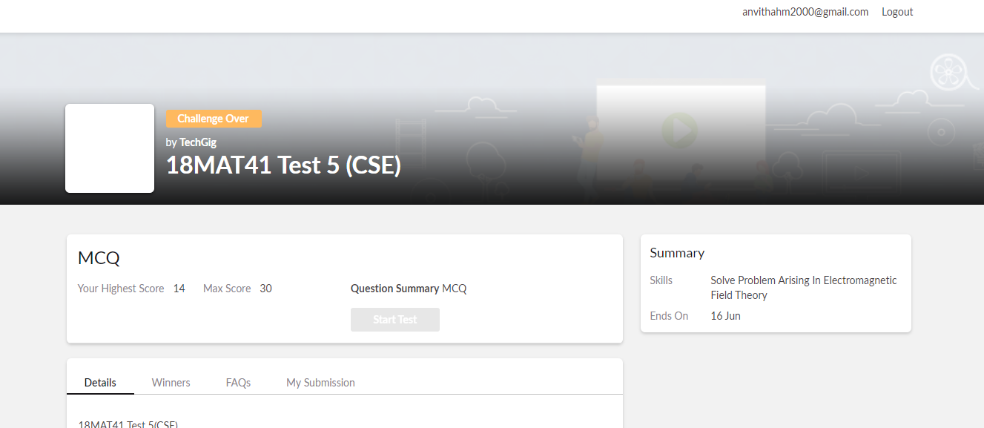

**Certification course:**

Tableau for beginners.

The course includes detailed explanation on Visualization of maps and charts in tableau and its type, scatter plots using filters, numeric calculation, working on string and function, datediff function and working on parameters.

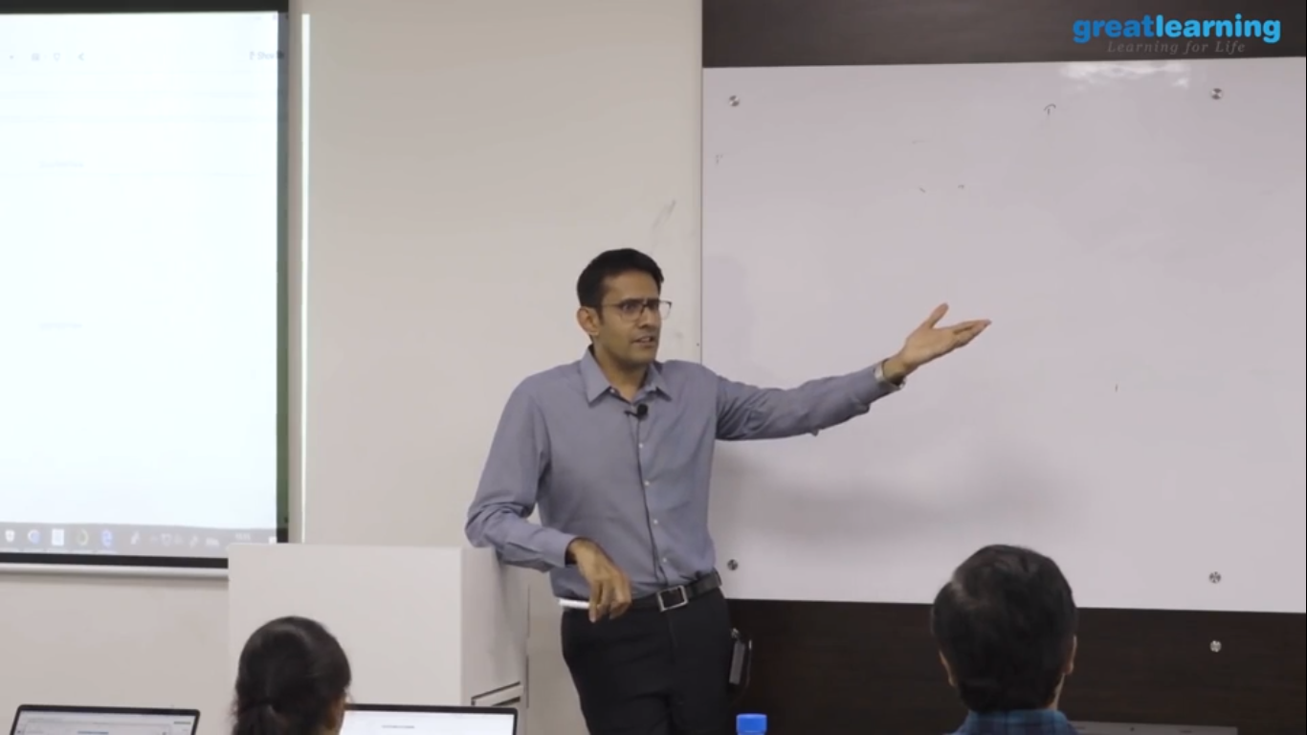

Online coding challenge

The programing statement of the day is

“program to binary reversal of a number”.

Solution: Executed and uploaded in Github repository.

Link: <https://github.com/alvas-education-foundation/Anvitha-H-M>

